The Always On Sales Control System
Streamlining the Path from Search to Insight
https://robtaylorofficial.github.io/Always-On-ROI/
ROI Calculator EMBED
Let me ask you something.
How many enquiries came into your business this month that didn’t get a response within three hours… and what did that cost you?
How many of your buyers had already decided what they needed before they ever spoke to your team… and where were you while they were doing that research?
If a prospect landed on your website today with a real problem, would they get a clear answer… or just another brochure?
And when your sales team finally gets involved, are they building on insight… or starting from scratch?
One more.
Where, in your current process, do leads slow down, get ignored, or disappear altogether?
Because they do.
Not through bad intent.
Through broken systems.
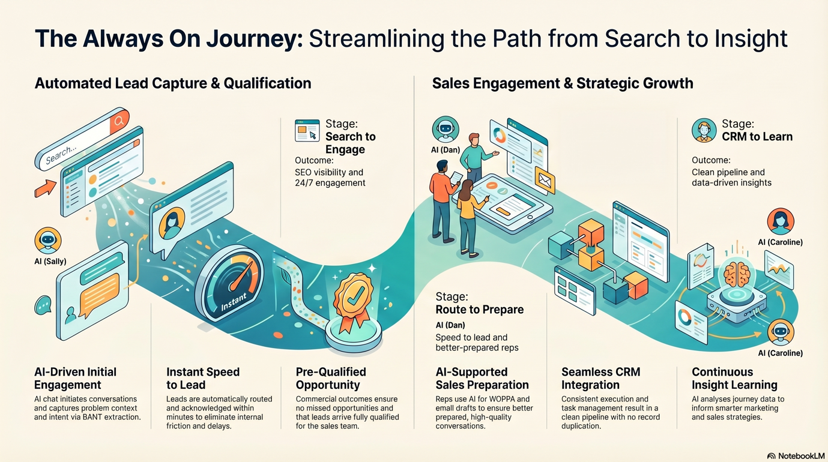

Here’s the reality.
Your buyers are already searching. Already learning. Already forming opinions.
They expect fast responses. Relevant answers. And conversations that move them forward, not hold them up.
But most sales and marketing setups weren’t built for this.
Marketing attracts. Sales react.
Leads sit in inboxes. Context gets lost.
Good opportunities become missed opportunities.
Not because your people aren’t good enough.
Because your system isn’t connected enough.
That’s the gap.
And that’s exactly what the Always On Sales Control System is designed to fix.
It connects the entire journey.
From the moment a buyer searches…
To the moment your team learns.
It captures demand early, through intelligent, always-available engagement.
It qualifies in real time, turning vague enquiries into clear, structured opportunities.
It routes instantly, so the right person responds with the right context, at the right time.
It prepares your sales team, so every conversation starts informed, relevant, and valuable.
And it closes the loop, feeding insight back into your marketing, your messaging, and your strategy.
No delays.
No duplication.
No missed signals.
Just one continuous, connected system.
Where buying and selling are aligned.
Where marketing doesn’t just generate leads, but generates understanding.
Where sales doesn’t just respond, but adds value from the very first interaction.
This isn’t about replacing your team.
It’s about enabling them.
To respond faster.
Prepare better.
And show up in the moments that actually matter.
Because in today’s market, the difference isn’t always your product.
It’s how easy you are to engage.
How quickly you respond.
And how well you understand the problem before you try to solve it.
So the question isn’t whether your buyers have changed.
They have.
The question is…
Have you built a system that keeps up with them?
Or are you still relying on one that was built for a world that no longer exists?
Welcome to Midshire Lubricants!
Walthrough video

The Always on Sales Control System
Embded video

